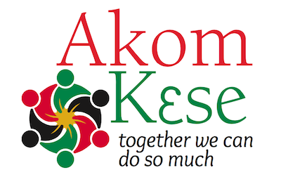
Akom Kese 2023
Richmond, Virginia

Friday August 4, 2023

Meet and Greet @ 6 pm to 8 pm

Host Hotel Embassy Suites by Hilton Richmond
2925 Emerywood Parkway, Richmond, Virginia 23294

Saturday, August 5, 2023 Virginia Union University
1500 N. Lombardy Street, Richmond, VA 23220
Location: Douglas Wilder Library

9 am Welcome/Opening Libation

9:15 to 10:00 am Ice Breaker

10 am - 10:15 am Council of Elders Update

10:30 am – 11:00 am Update on Burial Society

11 am - 12:00 Noon What are the roles of men and women in a Black family? Can traditional martial practices help improve our relationships?
12 noon to 1 pm Lunch on your own

1:00 pm - 2:00 pm The Blended Family Okomfo Nyoka Samuels- Gilchrist
2:00 – 4:00 pm Ancestral Healing
Traditional African Spirituality and the Liberation of Black Family and Nation Okomfo Kwabena Frempong

4:00 – 6:00 pm African Burial Ground (visit)

8:00 pm Group Dinner*

Sunday, August 6, 2023

7 am – 10 am Continental Breakfast Fellowship @ Embassy Suites

Suggested Donation: $25.00. Viewing Opportunity via Zoom - registration required

